**Recommendation to Enter the Short-Term Rental Market**

Prepared by Shiva Prabhushankar

Executive Summary

**Watershed ought to Enter the Short-Term Rental Market in stages, first converting the Top 16 Competitive Short-Term Rentals.**

46, 66, 67, 107, 108, 110, 120, 144, 152, 155, 156, 160, 163, 164, 190, 192

The analysis that serves as the basis of my recommendation shows Watershed will benefit from **$879,511 of increased profit during the first year** (conversion year), and yearly increased profits of **$783,511 each subsequent year**[1] my recommendation is enacted. Each converted location will remain **Cash Flow Positive, seeing $501,379 during the conversion year and $885,378 each year thereafter** this recommendation is enacted.

Following instructions from the Watershed Financial Department, the calculations above are based on a **Total Cash Investment of $500,000**.

Note, the required capital investment to necessary to convert all properties that beat the profitability threshold, is $1,230,000. Accordingly, Watershed stands to gain $1,373,212 of increased profits during the conversion year and $1,127,212 of increased profits every year thereafter. The business will maintain positive Cash Flows, seeing $389,212.49 during the conversion year, and $1,373,212.49 each year thereafter this recommendation is enacted.

This analysis is based on financial assumptions confirmed by both the company and industry experts. Sensitivity analyses further indicate that Watershed should enter the short-term rental market with their client, even if these initial assumptions need to be revised. Below, I describe the analyses and models used to arrive at my conclusions and report the results of my sensitivity analysis, quantifying how year-end revenue metrics and necessary capital expenditures change if the financial assumptions made are modified.

Project Introduction and Scope

It is no secret that people love to travel. Surprisingly though, travelers are vastly limited in their accommodation options. Typically bound to a run of the mill hotel / motel room, a suite, and in the rare cases a Bed and Breakfast.

A disruptive force has entered the market: listing apps that offer short-term rental options. Apps like AirBnb, Vrbo, and FlipKey allow property owners to rent out vacant properties, or spare rooms to travelers. Based on the continued success of these apps, it is obvious that travelers are enjoying this disruption, forgoing traditional options for a more personal feel. Travelers have shown that they are *more than willing* to pay the additional premium for this environment.

In an attempt to capture part of the short-term rental market, Watershed’s clients are asking about the possibility of transitioning their *stable* long-term investment properties into the risky short-term rental market. This project explores 244 individual rental properties, and reports the following:

1. Each property’s Nightly Rent
2. Each property’s expected Occupancy Rate
3. Relevant year-end financial metrics

Next Steps

Watershed is dually responsible to inform clients of the changing tides in the housing market and provide solutions that maximize the return property owners receive on their investment(s). Watershed *must* find ways to remain valuable to clients wishing to enter the short-term rental market.

There are a few ways this can happen:

1. Show clients dollar figures explaining what they stand to gain / lose from a potential transition
2. Provide lower barrier to entry costs
   1. Negotiating Lower Fees and Rates with Listing Apps
   2. Contracting Renovators
   3. Time
3. Provide Clear and Value-Added Management to Each Short-Term Rental
   1. Providing Low Key-Turn Costs by Negotiating with Hospitality Services
   2. Continually Optimize the Nightly Rental Rates
   3. Faster Cash Flow

Analysis Summary

To begin, I modeled the relationship between nightly rental price and occupancy rate for short-term rental properties using data from current short-term rentals managed by other companies and owners. I used this model to predict the short-term rental prices that maximize profits from each of Watershed’s client’s properties if it were managed as a short-term rental property. The metrics I report are based on the sum of the forecasted profits that would be gained and the forecasted capital investment that would be needed if my recommendation is followed, after the following are accounted for:

(1) initial furnishing costs, (2) upkeep costs, (3) internet service fees, (4) regulatory fees, (5) hospitality charges (including key service and cleaning), (6) typical duration of stay, and (7) utilities.

The details of the assumptions I used are provided below (Table 1), followed by a description of the results of my sensitivity analysis.

**Table 1**

|  |  |  |  |  |  |
| --- | --- | --- | --- | --- | --- |
| **Consideration** | **Assumed Value** | **Original Value Source** | **Minimum Value Tested** | **Maximum Value Tested** | **Rationale for Range of Values Tested** |
| Additional Profit Needed to be Considered a “More Profitable as a Short-Term Rental” | $6,000 | Watershed Financial Department | $2,049 | $8,049 | Min:  Current Avg LT Rent  Max:  Assumed Value  + Avg LT Rent |
| Cost to Convert Property to Short-Term Rental  (includes Furnishing and Decorating) | $30,000 | Watershed Marketing Department | $20,000 | $40,000 | ± $10,00;  Average Cost of a Large-Scale Home Repair |
| Years to Depreciate Capital Expenditures | 5 | Watershed Financial Department | 3 | 7 | ± 2 Years |
| Yearly Upkeep & Maintenance Costs | $6,000 | Watershed Marketing Department | $5,400 | $6,600 | ± 10% |
| Listing and Service fees to short-term stay app (e.g. Airbnb, Vrbo, Flipkey) | 20% | Watershed Marketing Department | 15% | 25% | ± 5% |
| Regulatory fees (Taxes, Potential Legal Fees, and Emergency Reserves) | 10% | Watershed Financial Department | 5% | 15% | ± 5% |
| Hospitality Charges (Key Service, Cleaning, Re-Stocking) | $100 | Watershed Financial Department | $80 | $120 | ± $20 |
| Typical Guest Stay Duration (days) | 3 | Watershed Marketing Department | 2 | 4 | ± 1 day |
| Monthly Utilities per Property | $300 | Watershed Financial Department | $150 | $450 | ± $150;  Average Monthly Utility Bill in the US |

As agreed, the below details were NOT incorporated into the analysis. (Table 2):

**Table 2**

|  |  |
| --- | --- |
| **Factor not included in analysis** | **Reason for exclusion from analysis** |
| Weekly or Seasonal Changes in Rental Prices / Occupancy Rates | Instructions from Project Manager |
| Effects of Promotions, Coupons, or Special Events | Instructions from Project Manager |
| Loss in Rental Income while Property is Converted | Instructions from Project Manager |
| Differences in Utility Costs Across Properties | Instructions from Financial Department |

I created a dashboard that demonstrates the effects of changing any and all of the assumptions made on predicted profits and required capital investments.

Link to Dashboard:

In Table 3 below, I enumerate the specific values that minimized and maximized projected profits

**Table 3**

|  |  |  |
| --- | --- | --- |
| **Consideration** | **Value in Assumption Set that led to Minimum Profits** | **Value in Assumption Set that led to Maximum Profits** |
| Additional Profitability Requirement | $8,049 | $2,049 |
| Conversion Cost  (includes Furnishing and Decorating) | $40,000 | $20,000 |
| Depreciation Period for Capital Expenses  (Years) | 3 | 7 |
| Upkeep & Maintenance Costs  (Each Year) | $6,600 | $5,400 |
| Listing Service Fees  (e.g., Airbnb, Vrbo, FlipKey) | 25% | 15% |
| Regulatory Fees  (Taxes and Potential Legal Fees) | 15% | 5% |
| Hospitality Charges  (Key Service, Cleaning, Re-Stocking) | $120 | $80 |
| Typical stay duration  (In Days) | 2 | 4 |
| Utility Cost  (Per Months) | $450 | $150 |

The minimum additional profits Watershed stands to gain when these assumptions are modified within the ranges above is XX, while the maximum additional profits are XX. Provided the “Top 16” properties are converted.

Note, the values for minimum and maximum additional profits Watershed stands to gain are XX and XX respectively if all the properties that beat the additional profitability threshold are converted.

Overall, the parameter that affected profits most was the Total Fees.

Predictive Modeling & Optimization Details

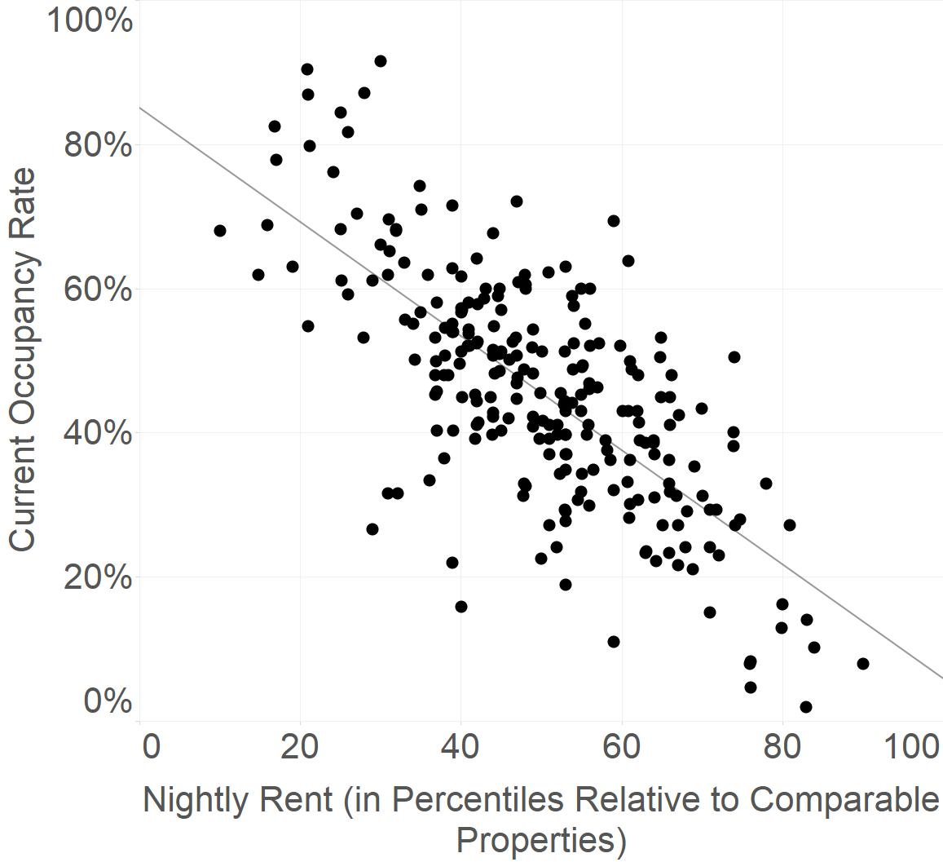

**Linear Regression Line:**

y = -0.79x + 0.85  
R² = 0.52

I was provided with four pieces of information about the short-term rentals of the same type (number of bedrooms, apartment or house, kitchen availability, unshared property) and location of Watershed’s client’s 244 properties: a typical short-term nightly rental rate, the corresponding occupancy rate for the property with that rental rate (x, y values respectively), the 10th percentile nightly rental rate, and the 90th percentile nightly rental rate. When typical rental prices were expressed in terms of percentiles relative to properties of the same type and in the same location—*but not when they were analyzed as raw dollar values*—they correlated linearly with occupancy rates. Using the parameters of this regression line and Excel’s “Solver optimization function” (Macro Enabled VBA), I was able to find the corresponding nightly rental prices that maximizes expected revenue for each property.

In this optimization, I set “goal-posts” at the 10th percentile and 90th percentile prices, respectively. Any optimized price that fell below the 10th percentile rate was replaced with the 10th percentile rate, and any optimized price that rose above the 90th percentile rate was replaced with the 90th percentile rate. This is to account for the lack of data outside these ranges in the linear model.

These optimized rental rates were then entered into a financial cash flow and profit model that computes the expected revenue for each property based on its projected occupancy rate, and the associated costs according to financial assumptions described above.

Closing Notes and Opportunities for Further Analysis

In spirit of Watershed’s operating philosophy of delivering exceptional client service, maintaining safe investment, and minimizing risk this analysis shows the following:

1. The current long-term rental model works. Converting an occupied, cash-flow positive, and profitable long-term rental into a short-term rental, *even with minimally associated cost*, will not guarantee a profitable result. In fact, **most properties analyzed will fall into this category**.
   1. Note, further analysis ought to be done to *ensure* long-term rents are optimized*.*
2. Only the converting properties that surpass the additional profitability requirement, even by conservative estimates, show that Watershed stands to gain tremendously in entering the short-term rental market.
3. In the set of “Profitable Properties”, there is a clear negative incremental gain for converting an additional property, i.e., the appropriate year-end revenue metrics do **not** increase in linear proportionality to the required conversion year capital expenditure.

Even with the limited scope of this analysis, there is a large amount of value. It stands to reason that in allocating additional time, capital, and data will show more interesting results. And of course, with additional data inputs, I can build a better predictive model that further reduces uncertainty and finds more value.

As previously stated, this analysis made necessary simplifying assumptions to meet various business requirements. The largest assumption made was that a nightly rental price and the corresponding occupancy rate for an individual property would remain stagnant throughout the year. This means we have *ignored* the effects of:

1. Marketing strategies i.e., loyalty programs, discounts, coupons, loss-leading and up charging;
2. Environmental, cyclical, seasonal factors;
3. Location Specific Events (sporting events, rallies, concerts, etc.).

These factors, as well as others, are known to effect nightly rental prices and occupancy rates.

Additionally, we assumed:

1. The Necessary Capital Expenses Required to Convert a Property is the Same Across the Board;
2. Upkeep and Maintenance Costs for each Property are the Same Across the Board.

A final word of caution on this analysis- this project *only* analyzed 244 available client rental locations, with a small number of descriptive features. Additional details of these properties are required, including but not limited to their square footage, distance to nearby points-of-interest, available amenities, and entertainment. Identifying the dispositive features that constitute a profitable short-term rental in the long run will in turn help Watershed:

1. Identify Future Growth Opportunities in this Market
2. Create an Assessment for Clients Wishing to Convert their Long-Term Rentals into Short-Term Rentals

Based on a reasonable degree of mathematical and scientific certainty, clients wishing to convert their current long-term rental properties into a short-term rental property are able to do so, provided their rental property is shown to surpasses the minimally accepted additional profitability requirement as set forth in this analysis.

Cheers

What we have done:

1. **Identify relevant project stakeholders, Elicit clear project guidelines, Understand a project’s scope, and Set an appropriate timeline for deliverables**

All projects are going to have twists, turns, and problems. But that is a bad, bad, bad excuse to dive head-first into a project without first clearly understanding the following, at a minimum:

1. Purpose- What can we expect this project to produce?
2. Necessary Information and Tools Available[2]- What ought we use to address the relevant business problem
3. Resource Allocation- How much capital, time, etc. are we willing to spend on this project?
4. Timeline of Deliverables- What timeline are the project stakeholders working on? What are the expecting from us after a certain period?
5. **Present a recommendation to stakeholders and decision makers, communicating the results of an analysis in the following formats: an interactive dashboard, a white paper, and a presentation.**

It goes without saying that decision-makers are busy individuals. The ability to communicate the results of an analysis in a brief, clear, and straightforward manner is integral to today’s fast-paced and ever-evolving world. A responsible data analyst ought to leverage their skills in communication, visualization, and reporting to quickly inform decision makers of relevant changes to their business, help others understand the findings of the analysis, and provide data-driven suggestions about optimal paths moving forward.

1. **Provide decision makers with important business metrics. Including reducing uncertainty, calculating the information gained with additional data, and quantifying the remaining model’s uncertainty**

An unfortunate reality is that no project is void of “uncertainty”. Any analysis that claims to “remove all uncertainty”, should be distrusted to the highest degree. What the responsible Data Analyst is left with is an ethical responsibility to provide decision makers with 1.) the appropriate and relevant business metrics to accurately make decisions and 2.) calculate the remaining uncertainty.

Skills Gained:

1. **Developing a Classification Model that groups into distinct categories.**

It is readily obvious that businesses need to understand their target audience. Following suit, an integral part of *finding* a target clientele / consumer base ought to be a critical aspect of a data-driven business project.

Specifically, this project classifies 244 properties into 3 distinct categories: Profitable & Convertible, Profitable but Not Convertible, and Not Profitable & Not Convertible.

1. **Shown that I, a Self-Taught Data Analyst & Programmer, can complete the entirety of a data project.**

The field of Data Science is vast, overwhelming, and most importantly *growing.* Navigating it properly requires professionally responsible agents capable of:

1. Understanding Specific Project Requirements, Pain-Points, and Business Requirements
2. Setting the appropriate Hallmarks of Success
3. Accurately Report the Bounds the Analysis Reveals

A tale of caution: we know that unsustainable growth can be deadly for institutions. Proper safeguards must be respected and adhered to; otherwise similarly bad results can occur. At a minimum, this field requires professionally responsible agents who are capable of navigating the entire strata of the business world.

Fin

1. The “Subsequent Year Period” calculates depreciation for the assets necessary to convert a standing Long-Term Rental Property into a Short-Term Rental Property.
2. It should be noted that an ethical data analyst **never** lets the available tools dictate the results of an analysis.